Follow-Along YouTube link: https://youtu.be/NAigMURgbyU

Making a New Database

Creating a Database in MongoDB:
1. Log into MongoDB
2. Connect to the MapStructor connection
3. On the connection, click the "plus" button
4. Give your database a meaningful name and set it as both the Database Name and Collection Name
5. Create collections (by clicking on the "plus" button on the new database you just created) so that the database has the following collections
- ButtonLink
- LayerData
- LayerGroup
- LayerSection
- Map
- MapFilterGroup
- MapFilterItem
- MapGroup
- User
- ViewOrderCounter
- ZoomLabel

Connecting the Database to the Project (.env file):
1. If you have a .env file in your project, add the following to it
DBNAME_DATABASE_URL = "..."
(replace with the name of the database from Creating a Database in MongoDB -
step 4)
2. In that .env file, replace the ... by copying the content from an existing X_DATABASE_URL, but replace ".../otherDatabaseName?retry..." with ".../DBNAME?retry..."
(replace with the name of the database from Creating a Database in MongoDB - step 4)

Connecting the Database to the Project (Vercel):
1. Log into Vercel
2. Click on your project
3. Click on the "Settings" tab at the top
4. On the left, click on "Environment Variables"

5. Where it says "Key" and "Value", copy the line you just added to the .env file and paste it into the "Key" box
6. Click on "Save"
7. You can (but you don't have to) click on "Redeploy". You don't have to because when you add the code and merge it into GitHub, Vercel will trigger a redeploy.

Your database has now been created and ready for your project!
Properly Copying the Necessary Files

** Line numbers are subject to change depending on further development. **

Make a New Prisma Schema:
1. In the folder /app/prisma/generated_schema, create a new folder with the name of your database (for instance, NorthAmericaLandowners)
2. Copy the contents of an existing schema-XXX.prisma file (don't copy schema.prisma, this is old)
3. In the /app/prisma folder, create a new prisma schema titled "schema-ABC.prisma" (change ABC to be a 3-letter acronym for your new database)
4. Paste the contents from the existing prisma schema into the new schema
5. At line 10 in this new schema, replace the existing "generator client {..." code with this
generator client {
provider = "prisma-client-js"
output = "./generated_schema/NameOfDatabase"
binaryTargets = ["native", "rhel-openssl-3.0.x"]
}
Change this to match the name of the folder you created in step 1 (and match your DB)
6. At line 18 in this new schema, replace with the following
url = env("DBNAME_DATABASE_URL")
(replace with the name of the database from Creating a Database in MongoDB -
step 4)
7. Next, you'll add scripts for generating this prisma schema. To do so, open package.json found in the main project folder
a. At line 6, where it says "generate_prisma", add "npm run gen_ABC &&" to the
beginning of that value
b. Copy an existing "gen_ABC" (just choose the one at line 7), and insert the copy above
it (so the copy is now at line 7)
c. Change the "ABC" to be that new 3-letter acronym you're using (there should be 4
spots you need to change in this new command)
8. Now you must generate the prisma schema to run locally (locally means running the project with "npm run dev"). Open your Command Terminal and navigate to the project folder (should be Mapstructor). Run the command "npm run gen_ABC"
(Change ABC to match the 3-letter acronym from step 3)

Copying the Necessary Content:
** When it says "subfolder", change that to the path you desire to have in the domain **
1. Create a new subfolder within the /app folder with the desired domain path. For example, if you wanted domain.com/X/Y, then create subfolder X, then inside folder X create subfolder Y
2. Find another existing subfolder (like /northamerica/landowners) and copy all the contents of that folder, which should include
- /page.tsx
- /login/page.tsx
- /components/ (the whole folder)
3. Paste the contents you just copied into the subfolder path you created in step 1. (Make sure to paste it in the lowest subfolder! - i.e., folder Y in the /X/Y path)
4. Make some minor modifications specifically for your project (Scroll to page 6 for additional instructions for what information is needed - relevant for substeps A and B)
a. Update the MapBox API access key in...
/app/subfolder/components/map/mapbox-compare.component.tsx
/app/subfolder/page.tsx
b. Update the MapBox style ID in...
/app/subfolder/page.tsx (lines 146 and 147)
c. Update the MapBox style links in...
/app/subfolder/page.tsx (lines 673 and 684)
d. Double-check the year range is correct (if applicable), which can be found in...
/app/subfolder/components/slider/slider-with-date-panel.component.tsx
- Change "moment("...", "YYYY-MM-DD")" (line 32) → middle year
- Change "minYear" (line 49) and "maxYear" (line 50)
- Change "sliderStart" (line 71) and "sliderEnd" (line 72)
- Change "moment("...", "YYYY-MM-DD")" (line 93) → max year
/app/subfolder/components/slider/ruler/ruler.component.tsx
- Change "sliderStart" (line 13) and "sliderEnd" (line 15)
e. Change the router for the login page
In file /app/subfolder/login/page.tsx, change line 88 to "router.push('/subfolder');"
5. Within the /app/api folder, create a new subfolder with the desired domain path. For example, if you wanted domain.com/X/Y, then create subfolder X, then inside folder X create subfolder Y
6. In the /app/api folder, find another existing subfolder (like /northamerica/landowners) and copy all the contents of that folder, which should include
- /auth
- /ButtonLink
- /layer
- /LayerData
- /LayerGroup
- /LayerSection
- /LayerSectionData
- /map
- /MapGroup
- /StandaloneLayers
- /ZoomLabel
7. Paste the contents you just copied into the subfolder path you created in step 5. (Make sure to paste it in the lowest subfolder! - i.e., folder Y in the /X/Y path)
8. Make some more minor modifications using CTRL+F to search for changes
a. Search for "@/prisma/generated_schema/..." in the following files and change it to be
"@/prisma/generated_schema/NameOfDatabase" (change to be the same name as Make
a New Prisma Schema - step 1)
** IMPORTANT NOTE: Check for multiple results of the search! They will only appear towards
the top of the file with the other "import" lines. There should only be 1 file (highlighted in this
color) that has multiple results, but just double-check **
- Check all of the "/app/api/subfolder/" files
- /app/subfolder/components/forms/LayerForm.tsx
- /app/subfolder/components/forms/LayerGroupForm.tsx
- /app/subfolder/components/forms/MapForm.tsx
- /app/subfolder/components/forms/NewLayerSectionForm.tsx
- /app/subfolder/components/forms/NewMapGroupForm.tsx
- /app/subfolder/components/forms/ZoomLabelForm.tsx
- /app/subfolder/components/layers/layer-group-section.component.tsx
- /app/subfolder/components/layers/layer-group.component.tsx
- /app/subfolder/components/map-filters/map-filters-group.component.tsx
- /app/subfolder/page.tsx
b. Ignoring the "/app/api/subfolder", search for "/api/..." and change it to "/api/subfolder/"
for the other files above as well as the files below
- /app/subfolder/login/page.tsx
- /app/subfolder/components/map-filters/map-filter-wrapper.component.tsx
- /app/subfolder/components/layers/layer.component.tsx

After all this, you must modify the file "/app/page.tsx" to redirect to this new page. That's up to you; it could be adding a simple button or having some interaction.

Once this code is merged into the main branch, the subfolder will be an active page on the site!
Relevant MapBox Stuff

Properly Copying the Necessary Files - Step 4:
1. For this step, you need to access various information. Therefore, here are some steps for finding that information to update everything for incorporating a different MapBox account
2. The first thing to change is /app/subfolder/components/map/mapbox-compare.component.tsx
a. Navigate to your MapBox account
b. Click on "Style editor"
c. On the style you wish to have, click the button below

d. A pop-up will appear, scroll to the bottom where it shows the following (take note of the information outlined in the red box, as this is important
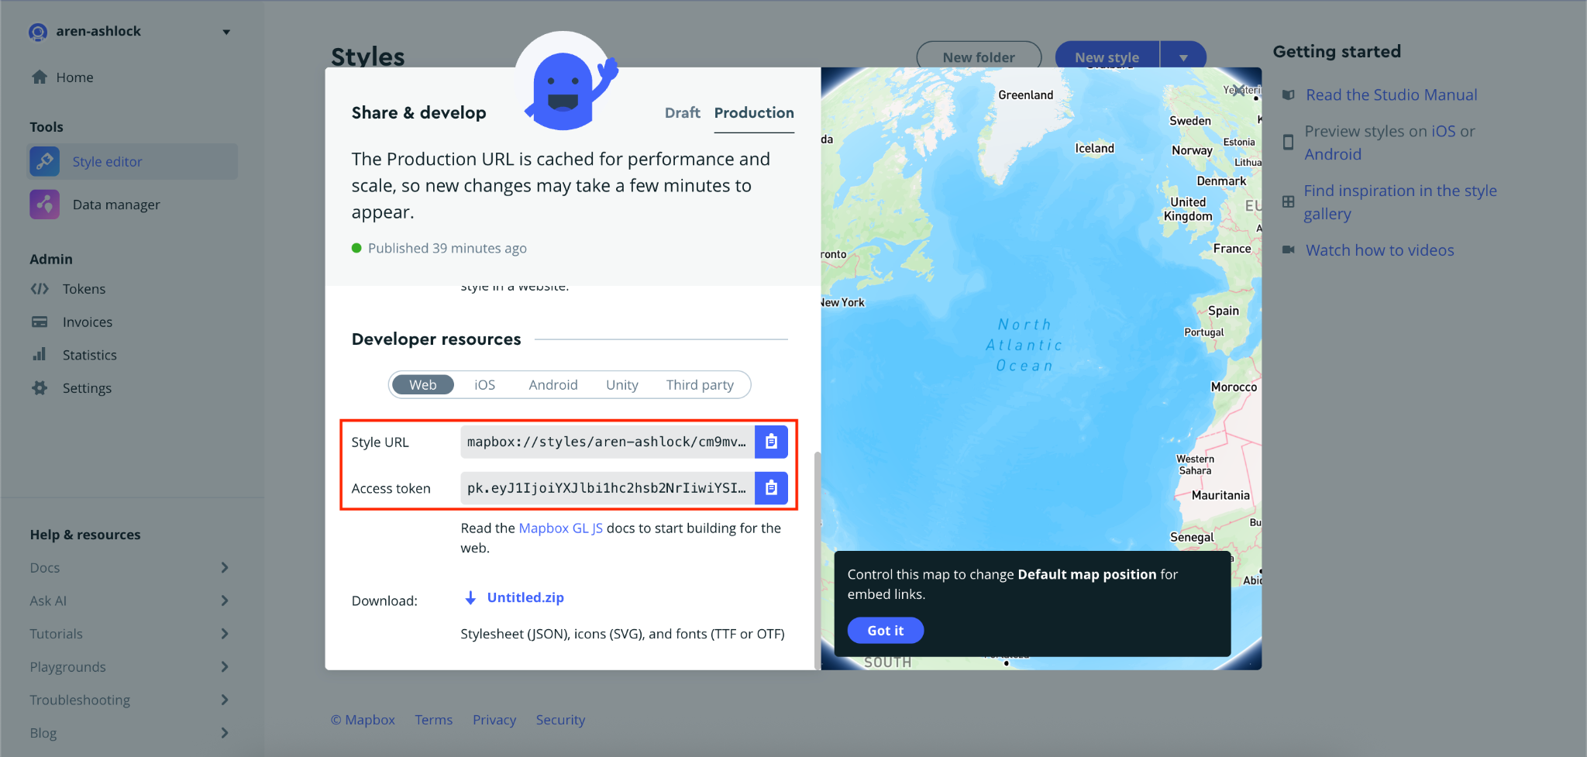
e. In /app/subfolder/components/map/mapbox-compare.component.tsx, replace the access token in line 6 with the access token found on this page
f. In /app/subfolder/page.tsx, replace the access token in line 71 with the access
token found on this page
3. While this information is pulled up, we also need to change stuff in /app/subfolder/page.tsx
a. Copy down the Style URL and change the following...
- defBeforeMap { ... style ... } (line 673)
- defAfterMap { ... style ... } (line 684)
b. Then, just copying the end of that Style URL, change the following...
- setBeforeMapItem({ ... mapId .. }) (line 146)
- setBeforeMapItem({ ... styleId .. }) (line 147)

Uploading a layer to the site:
1. When you log in to the site and try to upload data, most of it is up to the user. However, there are a couple of very important things to keep in mind...
2. Navigate to your MapBox account, click on "Data manager", and then click on the layer you want to upload
a. For "Source Type", select "Vector" from the drop-down options
b. For "Source URL", add the information highlighted here (you will need to copy the
highlighted stuff and add "mapbox://" to the beginning -- this is shown in the next
screenshot)
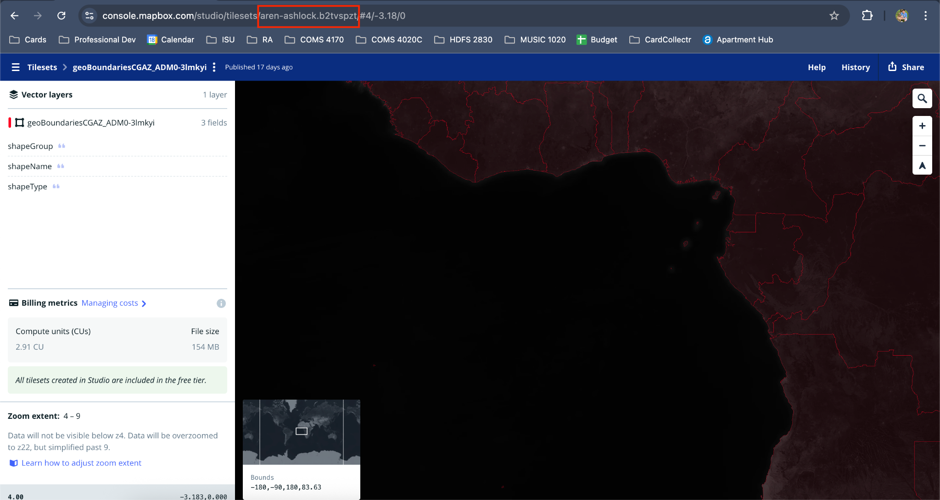
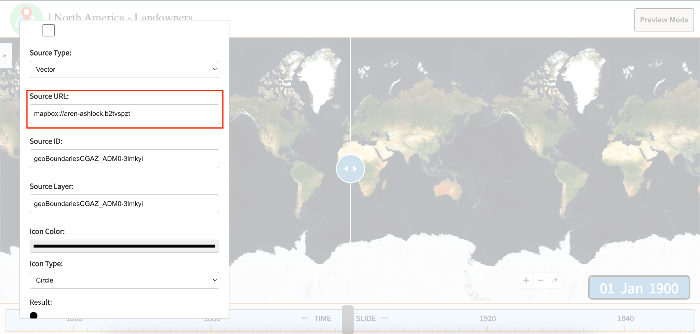

c. For "Source ID" AND "Source Layer", add the information highlighted here
